Name:- Gaurang A Raorane

Roll no:- 49

D15A

Aim :- Install and Spin Up a Kubernetes Cluster on Linux Machines/Cloud Platforms.

Sudo apt-get update

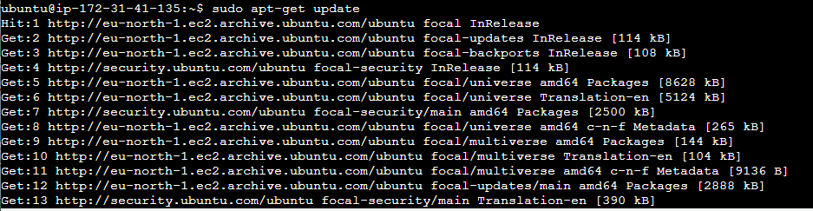

Sudo apt-get install docker.io

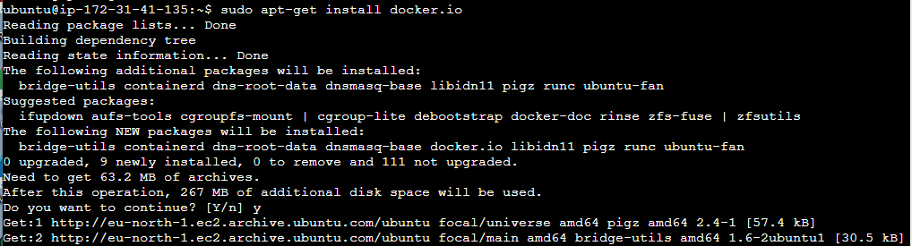

Sudo systemctl enable docker

Sudo systemctl status docker

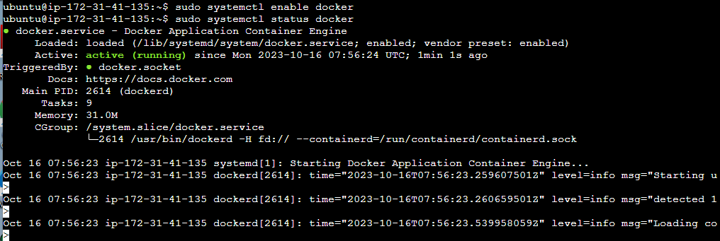

Docker is up and running



Checked the containers using sudo docker container ls command

Sudo apt-get update

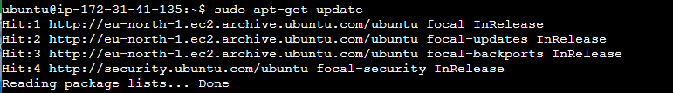

Sudo apt-get install -y apt-transport-https ca-certificates curl

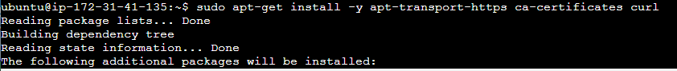

Sudo apt-get install -y kubelet kubeadm kubectl

